Introduction possible

Models of language production assume that the process of producing a single word is comprised of various encoding stages (Levelt et al., 1999). These include a conceptualization stage, followed by the selection of a particular lemma to be expressed, and finally, word form encoding and articulation. Although we have estimates of the time course of the different stages of word production (see for example, the meta-analysis by Indefrey & Levelt, 2004), considerable variation in naming latencies is typically observed among individuals (Laganaro et al., 2012). Several previous studies have investigated potential sources of this variability and have found evidence that individual differences in various measures of cognitive function predict variability in the time needed to produce a single word (e.g., Jongman, Roelofs, et al., 2015; Shao et al., 2012, 2013, 2015). However, many questions remain open. First, there is some evidence that task difficulty may modulate the relationship between cognitive function and naming latencies (e.g., Piai & Roelofs, 2013). Second, it is still unclear whether the predictive power of certain cognitive skills for word production speed is limited to the language domain, or whether domain-general measures of cognitive function are similarly predictive of word naming speed. Testing these questions can provide insight into the broader question of whether (or to what extent) language is constrained by domain-general cognitive processes.

**Individual differences in cognitive skills predict word naming latencies**

**Task difficulty may modulate the relationship between cognitive measures and word production**

D provide evidence that the production of words partially depends on the availability of attentional resources.

More precisely, it seems that earlier encoding stages (conceptualization and lemma selection) display more reliance on attentional resource than later ones (Garrod & Pickering, 2007), although there is a debate concerning the dependency of phonological processing to attentional resource (Cook & Meyer, 2008).

A series of studies (Jongman, Roelofs, et al., 2015b; Shao et al., 2012, 2013, 2015) tried to link more precisely which subcomponent of the attentional system (Posner & Petersen, 1990) could explain inter-individual variability in the production of words. Through a correlational approach, authors tried to link metrics reflecting inter-individual difference in sustained attention (Jongman, Roelofs, et al., 2015b) and components of the executive controls (Shao et al., 2012) to metrics reflecting inter-individual differences in language production. (Shao et al., 2012) examined the contribution of the inhibitory component, the updating component, and the shifting component of executive control (Miyake et al., 2000) to metrics representing inter-individual variability in naming latencies. The task they used to assess metrics of executive controls were non-linguistic tasks. They used the stop signal reaction task (SSRT; (Logan & Cowan, 1984)) to assess inter-individual variability of the inhibitory component, the operation span task (OSpan; (Turner & Engle, 1989)) to assess inter-individual variability of the updating component, and shape-colour switching task (Meiran, 1996) to assess inter-individual variability of the shifting component. Variability of these components was correlated with parameters representing the distribution of naming latencies for objects and actions naming. These parameters were the mean, and the µ, σ and τ parameters obtained from the ex-Gaussian analysis of the latencies distribution (Balota & Yap, 2011; Tse et al., 2010). The µ and σ parameters represent the mean and the standard deviation of the Gaussian part of the distribution, and the τ parameter reflects both the mean and standard deviation of the exponential part of the distribution. Authors observed that there was no correlation between the shifting metrics and any of the parameters of naming distribution, either for action or objects. The updating ability correlated with the τ parameters of both the action and object naming, but did not affect the µ parameter. It suggested that updating abilities were not predictive of the overall speed of trials, but rather predictive of the proportion of slow trials. Inhibition ability correlated differently parameters of action and object naming: For action naming, inhibition correlated with the µ parameter, while for object naming, it correlated with the τ parameter. These results suggest that updating might be not be systematically contributing to naming latencies. On the other hand, inhibition seems to be involved in most trial of action naming, and only in few trials of object naming. This finding suggest that both of the updating and inhibiting would be involved in the production of words in a few and eventually difficult trials.

The assumption that the influence of updating abilities on word production might be limited to difficult trials seems to be in agreement with the finding of (Piai & Roelofs, 2013). These authors demonstrated that in a dual task context of production (i.e. producing the name of object while performing a tone discrimination task), participants’ updating abilities correlated with their mean naming latencies. Together, finding of (Shao et al., 2012) indicate that in a context in which the production of object name is the only task to perform, updating abilities correlate with the tail of latencies distribution, while by increasing the difficulty of the production task, employing a dual task paradigm, updating abilities correlate with the mean of the distribution. Therefore, these finding seems to suggest a form of differential mobilization of cognitive resource depending on the experimental context, with the updating component of cognitive control mobilized in most of the trials within context of increased production difficulty, and only in a few trial in easier production context.

(Jongman, Roelofs, et al., 2015b) investigated the involvement of sustained attention in language production, also relying on an inter-individual correlational approach. Sustained attention was measured by relying an independent non-linguistic continuous performance task (CPT; (Ballard, 2001)). In the second experiment of their study, they asked participants to name object either in a single task context or in a dual task context. They observed that the τ parameter of the distribution latencies correlated with the metric of sustained attention for both task, although the correlation was significantly higher for the dual task context. Moreover, the first experiment of the same study demonstrated that in a dual task paradigm, naming latencies correlated with the metric of sustained attention while gaze duration did not. It therefore seems that sustained attention would be involved in the later stage of word production, with this effect being particularly apparent in dual task context.

In three different studies, (Shao et al., 2012, 2013, 2015) investigated the effect of the inhibitory component of executive control on word production. Among these studies a distinction was made between a selective and a non-selective form of inhibition (Forstmann et al., 2008). The non-selective form of inhibition refers to the ability to suppress any unwanted response, and is usually the form that is assessed by using SSRT (Logan & Cowan, 1984) .The selective form of inhibition refers to the ability to suppress non-relevant and prepotent responses within a particular context, with the Simon or Flanker tasks assessing this form of inhibition. While non-selective inhibition metrics were obtained by making use of the SSRT, which is a non-linguistic task (Shao et al., 2012, 2015),selective inhibition metrics were obtained from the picture word interference task (PWI; (Glaser & Glaser, 1982)), with reaction times analyzed following the delta plot procedure (Ridderinkhof, 2002; Ridderinkhof et al., 2005) to extract inhibitory metrics. In (Shao et al., 2012), inter-individual SSRTs performances correlated with different parameters of the distribution, depending if the item to be named were object or actions. While this finding was replicated in (Shao et al., 2013), it was not replicated in (Shao et al., 2015). The selective form of inhibition might be of greater relevance for encoding stage of word production. One theoretical account of word production assume lexical selection is the product of a competitive process (Levelt et al., 1999). Hence, competitors to the relevant lemma need to be inhibited. In the context of the PWI task, a picture (the target) is presented to participants along distractor words sharing some properties with the target. The most commonly used manipulation involves presenting either distractor that are semantically related to the target or unrelated to the target. By making use of this paradigm, authors advocating for the competitive account of lexical selection assume that the presence of a semantically related distractor induce higher level of activation of competitor to the relevant lemma to be selected. As a consequence, competitors would need to be inhibited, a mechanism that would be time consuming. The classical finding of the PWI paradigm is usually longer naming latencies in the related than in the unrelated condition. (Shao et al., 2013, 2015) made use of this paradigm to characterize both the interference effect induced by the distractor, but also for establishing a metric of inhibition, relying on the delta plot procedure. Results shown that interfering effect observed in the PWI were correlated to the inhibitory metric established by the delta plot procedure. Interestingly, in (Shao et al., 2015) authors made use of the semantic blocking task paradigm (Damian et al., 2001) . In this paradigm, series of picture to be named are presented. In the homogenous condition, the series of pictures presented belong to the same semantic category. In the heterogeneous condition, the picture does not belong to the same semantic category. It is usually observed that naming latencies increase in homogenous series, because at each presentation of a picture belonging to the same semantic category as the previous one, the level of activation of the competitor would increase. (Shao et al., 2015) observed that the interfering effect in this task also correlated with the inhibitory metric derived from the delta plot analysis. So, in the presence or in the absence of a physical distractor, it seems that selective inhibition, established through a metric obtained within a linguistic task, correlate with semantic interfering effect. Non-selective inhibition, on the other way, is not constantly found to affect naming latencies.

Components of the attentional system therefore seem to be involved in single word production. However, this involvement seems to depend on the difficulty of the task and of the item to be named. As discussed above, effects of attention on word production are typically larger in experimental contexts such as the dual task paradigm for sustained attention, when the task is more difficult (Jongman, Roelofs, et al., 2015b; Piai & Roelofs, 2013). related to metrics derived from interfering paradigms in the case of inhibition (Shao et al., 2013, 2015) Furthermore, measures of attention do not seem to affect object naming and action naming to the same extent, and action naming has been argued to be more difficult than object naming (Shao et al., 2012). It is interesting to note that a recent review conducted on neuroimaging studies (Riès et al., 2016) emphasize on the involvement of left prefrontal regions in lexical selection, with the hypothesis that in challenging situation for healthy participant, or following a stroke, right counterpart of this area could be additionally recruited (see also (Geranmayeh et al., 2014)).

The current study addresses two main questions. First, we test whether relationships that have been found between components of the attentional system and word naming latencies change when the task is more difficult. Second, selective inhibition as measured by tasks involving language have been found to predict word naming latencies. We seek to determine whether this relationship is limited to the language domain, or whether domain-general measures of selective inhibition also predict word naming latencies.

In order to manipulate the difficulty of the task we rely on a procedure by which the urge of participants to name pictures is manipulated. In order to do so we are relying on a classical PWI paradigm, and we manipulate the context during which the PWI task need to be performed. The context is manipulated by having within the PWI procedure filler items. These fillers items are similar to the test items, except that their duration is either a constant value (equal to the duration used for the test items) or a varying value (shorter than the duration of the test items, see Method for details). To be clear, within one block of the PWI task, we are making use of filler items with either short or varying duration, for the purpose of giving the impression that the task is difficult (when fillers have a short duration). This manipulation allows us to manipulate the perceived difficulty of the task and to keep the characteristics of the test items constant.

We predict that individual measures of attentional components (name them here) will be more strongly related to the time it takes an individual to produce single words in a perceived difficult context than in the standard version of the PWI task (i.e., when all items have the same duration). ***Say what this would mean/what theory it would support***

Methode possible

Participants

Forty-eight participants, ages 18-30 (mean = 23.2, SD = 3.5), took part in the experiment. All participants were right-handed native speakers of German, and they reported having typical hearing and no psychiatric, neurological, or language disorders. Their participation was rewarded either by course credit or money. Participants were given details about the experimental procedure, and they provided their informed consent before starting the experiment. The study received ethical approval by the Ethical committee of the University of Potsdam (Germany).

Overview of the experiment

The experiment was conducted in two sessions. In the first session, participants performed a PWI task (Glaser & Glaser, 1982) and three tasks linked to the PWI material: a recall task, a delayed naming task, and a reading task. After these tasks, they performed the following tests: the German MWT-B (Mehrfachwahl-Wortschatztest, Version B; (Lehrl, 1975)); the Coding subtest of the Wechsler Adult Intelligence Scale- Fourth Edition (WAIS-IV; (David Wechsler, 2008)); the digit span forward and backward subtest of the Wechsler Memory Scale Revised (D. Wechsler, 1948) and the Corsi Block-Tapping Task forward and backward (Corsi, 1973). During the second session, we administered three span tasks to assess participants’ updating abilities. sustained attentional abilities by making use of 2 tasks, and non-selective and selective inhibition by making use of 3 tasks (see below for a description).

First session tasks: PWI and associated tasks

Figure 1 gives an overview of the PWI procedure and the following tasks attached to it.

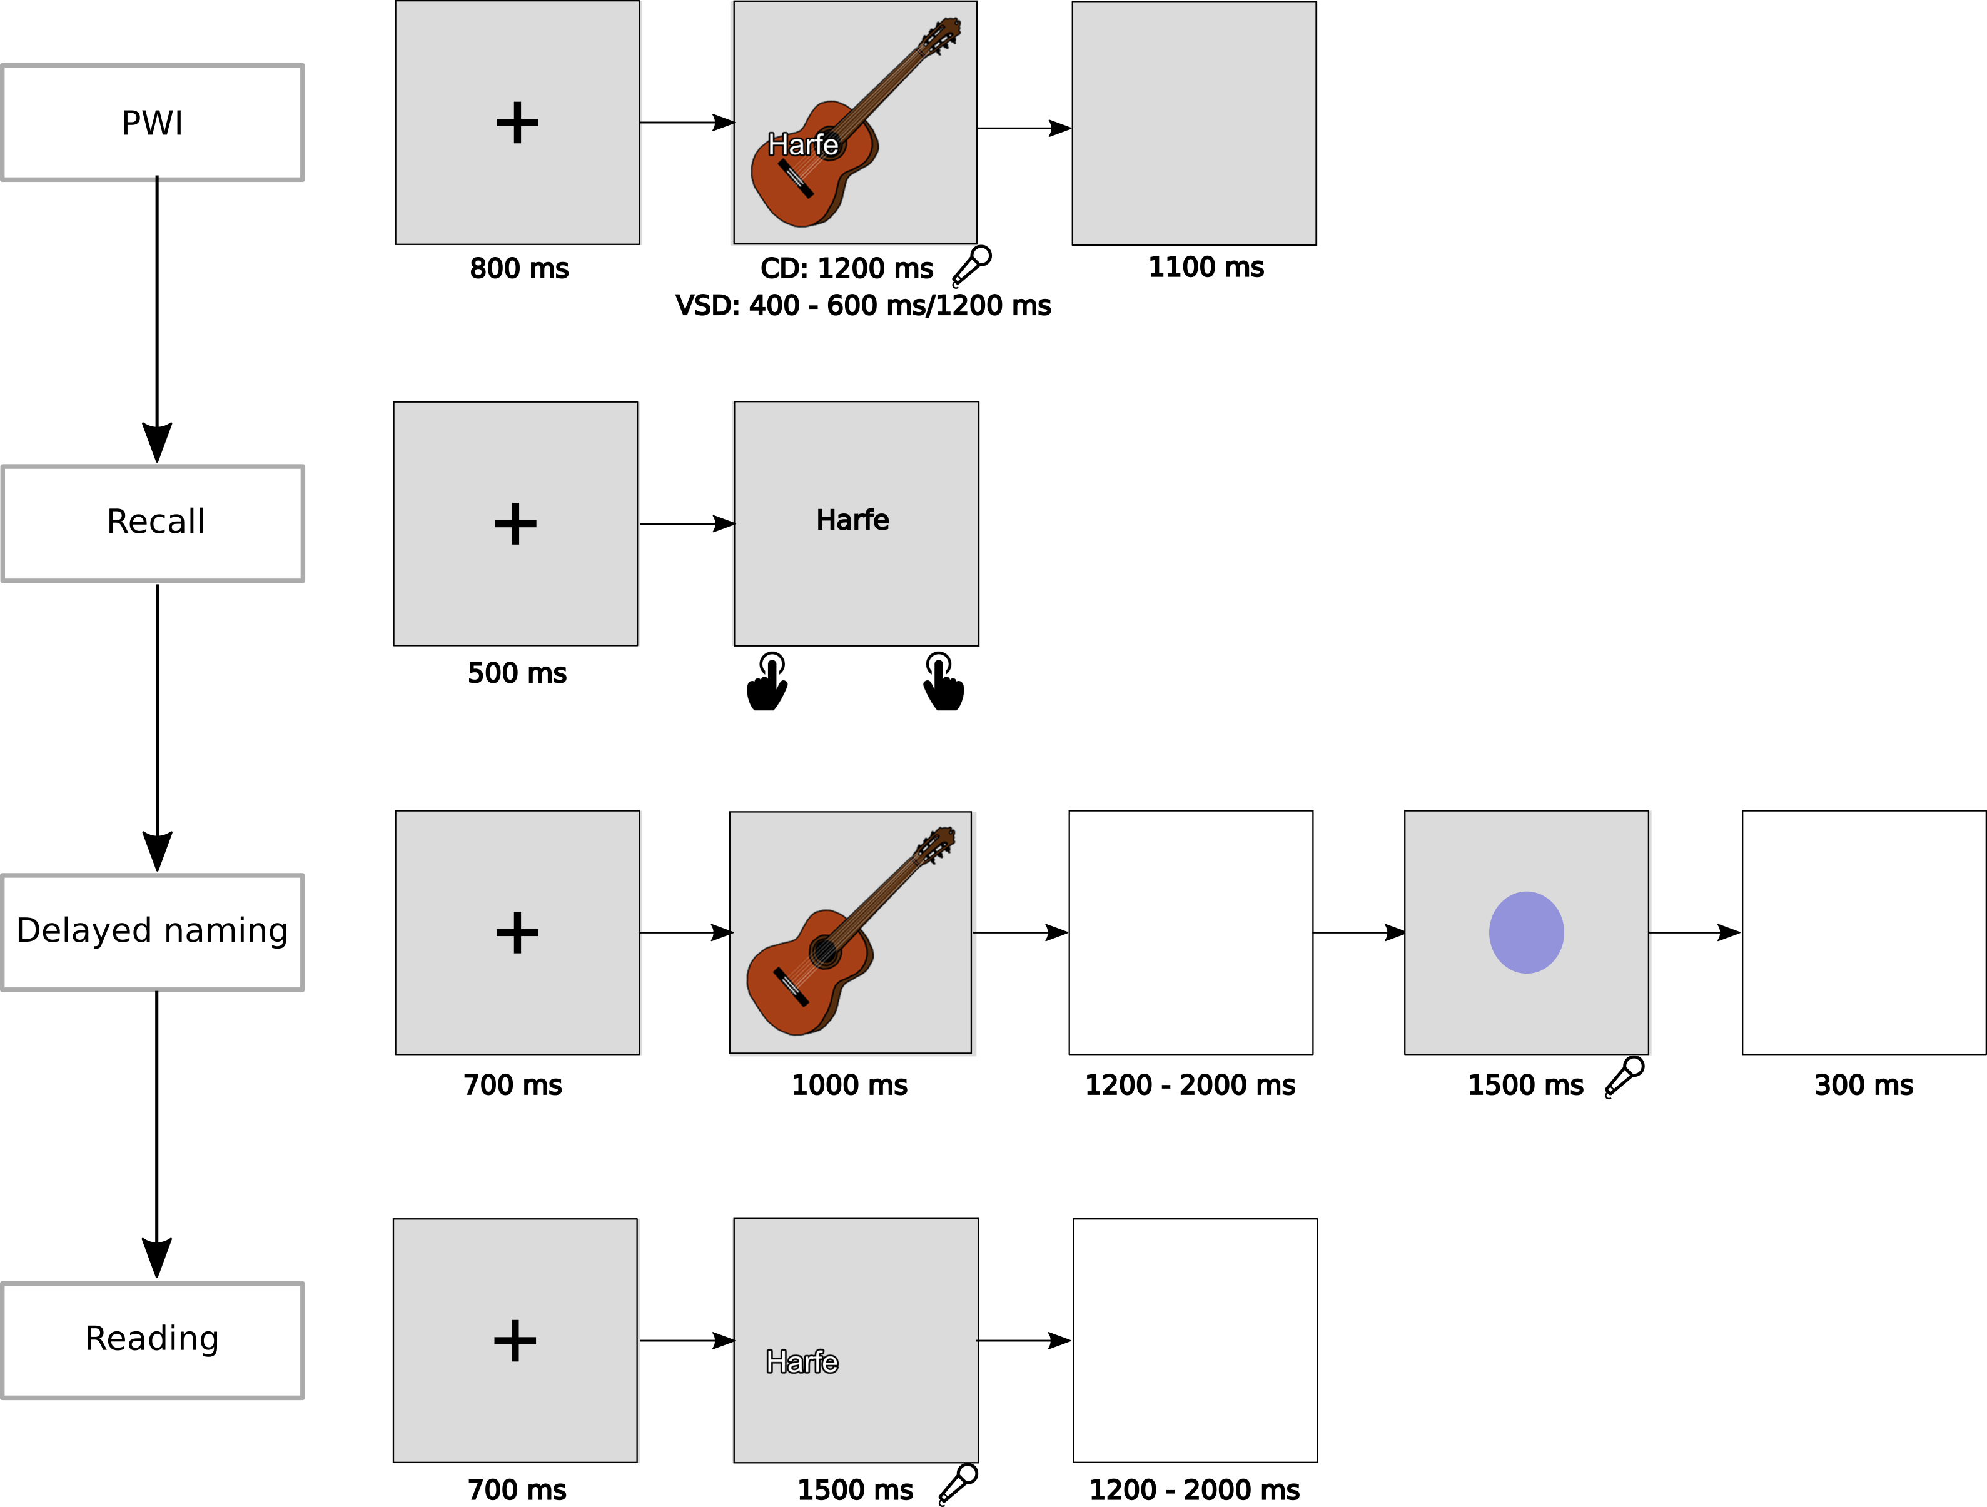

Figure 1: Part of the tasks used in session 1, with a representation of a trial

Picture word interference paradigm

Material

The material used in the PWI task is constituted of items that will be referred as “test items” and “filler items”. Only the test items are analysed; the filler items are only used for inducing the contextual effect described below. We selected a total of 142 Germans nouns (thereafter “target words”) and their corresponding pictures in the Multipic database (Duñabeitia et al., 2017), see Appendix 1). Ninety of these pictures were used for test items, 44 for filler items, and 8 for training items.

Experimental conditions

Each of the pictures was combined to 5 different character strings. The relationship between the picture and the character strings defined the experimental condition. These 5 experiment conditions were a baseline condition, a semantically related condition, a semantically unrelated condition, a phonological related condition, and a phonological unrelated condition. For the baseline condition (B), each picture was combined with the string “Xxxxxx”. For the semantically related condition (SR), each picture was combined with a distractor word from the same semantic category (e.g., two animals, two tools). For the semantically unrelated condition (SU), each picture was combined with one of the distractor words used in SR, controlling that the target word did not share semantic or phonological properties with the distractor word. For the phonologically related condition (PR), each picture was combined with a distractor word overlapping in the first phoneme(s) with the target word (between 1 and 4 phonemes in common at the onset of the word, for a mean of 2.62, and a standard deviation of 0.67). For the phonologically unrelated condition (PU), each picture was combined with one of the distractor words used in PR, controlling that the target word did not share semantic or phonological properties with the distractor word. Figure 2 provide an example of the target picture banana and the associated SR, SU, PR, and PU conditions.

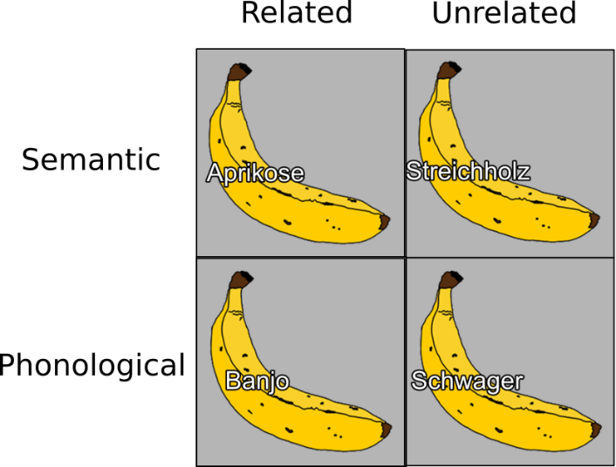

Figure 2

Structure of the task and description of trials

The training, filler, and test items were divided into two sets (Set A and Set B). Each set consisted of 20 training trials (4 targets in 5 conditions), 110 filler trials (22 targets by 5 conditions), and 225 test trials (45 targets by 5 conditions). There were two series of a familiarization block, followed by a training block, followed by an experimental block. Within one series, the items used either belonged to the set A or to the set B. During the familiarization, all of the pictures of set A or set B were used. These pictures were displayed along their name in a written form (see Figure 1). Participants were instructed to look at the pictures and to silently read their names, then to press a button to advance to the next picture. Participants were told they would have to give the displayed name of the pictures in another part of the experiment. Familiarization was followed by a training block that included 20 trials. Results from the training part were discarded form further analyses. The procedure used for the training was as follows: a fixation cross appeared for 800 ms, followed by the onset of one of the training item. Participants were instructed to produce the name of the picture as fast as possible. The duration of the item on the screen depended on the experimental condition difficulty. Either the picture could appear for a duration of 1200 ms, or for a duration ranging from 400 ms to 600 ms (see details below for further explanation). We refer to the condition for which all items had a duration of 1200 ms as the *constant duration* condition and the condition for which items had a duration ranging from 400 ms to 600 ms as the *varying short duration* condition (see below for more details). After the training, participants performed a block of experimental trials. This block embedded both filler trials and test trials. The procedure was similar to the one used in the training part, except that every test item had a duration of 1200 ms, while the duration of the filler items embedded within the same experimental block could either be constant and equal to 1200 ms for the constant duration condition, or could vary from 400 ms to 600 ms for the varying short duration condition.

After the first series of familiarization, training, and test block a second one occurred. Each participant started by a particular set (A and B) in a particular experimental condition of difficulty (CD or VSD). We counterbalance for this combination every 4 participants.

For the VSD condition, the duration of the fillers ranged from 400 to 600 ms, by discrete step defined by the refresh rate capacities of the monitor (60 Hz). Each of these durations was associated to a probability. This probability defined the chance of having a particular filler lasting for a particular duration. This probability was defined as half of a normal function, with µ = 600 ms and σ = 90 ms. Figure 3 illustrates the function applied to the total number of fillers used (110 within one block). These values were rounded in the experiment to fit an integer value indicating the number of trials by duration.

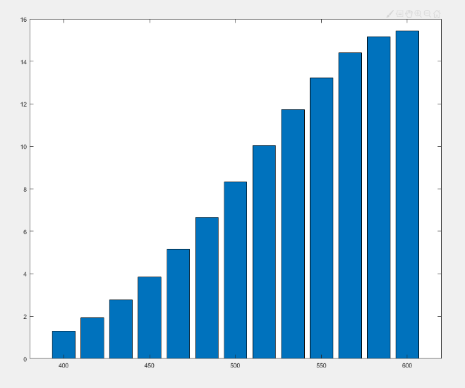

Vocal responses were recorded at a sampling rate of 44100 Hz and for a duration of 2000 ms. During the preprocessing, we checked for the onset of each vocal file manually, using Praat, and we noted if the responses were correct, incorrect, presented dysfluencies, or if there were no responses at all. This preprocessing was limited to the item tests. All of the other vocal files corresponding to either training items or fillers items were discarded.

Recall task

During this task we presented to the participant the full set of distractor words that were used during the procedure for the test trials. In total there were 180 distractor words (90 for the semantically related condition, 90 for the phonologically related condition) that were used, to which we added 180 words that were not used. A trial was as follows (see Figure 1): a fixation cross was displayed for 500 ms and replaced by a distractor word in the middle of the screen. Participants were asked to indicate if they had seen the distractor during the procedure or not by pressing one of two designated keys on the keyboard.

Delayed naming task

During the delayed naming procedure, we displayed every test picture (90) used during the experiment. The task of the participants was to wait for a signal to produce the name of the picture. A trial was as follows (see Figure 1): a fixation cross was presented for 700 ms, and replaced by a picture for 1000 ms. A blank interval, with a random duration ranging from 1200 to 2000 ms followed, and was replaced by a blue circle for 1500 ms. An interstimulus interval of 300 ms followed. Participants had to give the name of the picture only at the onset of the blue circle. They were instructed to avoid any articulatory preparation when waiting for the blue circle to appear. Vocal responses were recorded and we manually corrected for the onset latencies by using Praat. Vocal responses were recorded at a sampling rate of 44100 Hz and for a duration of 2000 ms.

Reading task

In the reading task a fixation cross first appeared for 700 ms. It was replaced by a word. This word corresponded to one of the distractor used for the test items during the PWI procedure. The position on the screen of the word was the same as the one we used for the PWI items. Participants had a maximum of 1500 ms to read aloud the word. Then an inter-stimulus interval of a random duration, ranging from 1200 to 2000 ms followed. Vocal responses were recorded at a sampling rate of 44100 Hz and for a duration of 2000 ms, and we manually corrected for the onset latencies by using praat.

Second session tasks: updating, inhibiting and sustained attention tasks

Following previous works on the relationship between language production and domain-general cognitive abilities, we included tasks to measure participants’ updating, sustained attention, and inhibition abilities. The choice of tasks used for measuring these abilities is not straightforward, either because these tasks have been shown to poorly correlate with each other while being supposed to measure a similar underlying construct, or because the metrics that can be assessed with these tasks can suffer in their abilities to capture inter-individual variability.

The rationale for the selection of tasks was as follows: in order to replicate and extend previous finding in the word production literature, we included tasks that have been previously used. Moreover, we followed recent recommendations originating from the literature on the cognitive functions we are interested in. As a result, we relied on additional tasks compared to the one previously used in the literature, and we also derived from these tasks different metrics compared to what has been previously used.

In the following part we will give a brief overview of our rationale for the selection of the tasks we used to measure each cognitive function (updating, inhibition, and sustained attention), and for the way we computed metrics for each. The issue with this approach is that it leads to an inflation of the number of the statistical tests than can be conducted. For this reason, we will specify which tests and metrics are planned analyses and which are exploratory.

Tasks measuring updating ability and metrics used for characterizing it

Working memory is often evaluated using span tasks (e.g., (Conway et al., 2005)). In such tasks, participants are asked to remember target items (e.g., letters) whose presentation alternates with the presentation of a secondary and demanding independent task (i.e., distractor items, e.g., resolving arithmetic problems). As suggested by various authors (Conway et al., 2005; Engle et al., 1999; Shipstead et al., 2012) , participants score in such tasks are not independent from the intrinsic properties of the task. For instance, two participants with the same working memory capacities but different arithmetic skills will likely obtain different scores in the operation span task. To decrease the influence of participant-specific skills in the secondary task, we administered three span different tasks, namely the operation span task (e.g. (Unsworth et al., 2005), the symmetry span task (e.g. (Unsworth et al., 2009), and the rotation span task (Harrison et al., 2013), and computed a composite score of these tasks. We administrated two blocks of each of these tasks, following the recommendations of (Foster et al., 2015)[1]. Each task consists in sequences of target (i.e., to be remembered) items and distractor items. After each distractor item, participants must provide an answer. At the end of each sequence, they must recall all target items, in the order in which they were presented during the sequence. In the *operation span task*, a sequence consists in the alternative presentation of an arithmetic problem and a letter. The letters are the to-be-remembered items while the arithmetic problems are the distractor items. Participants have to provide a response for each arithmetic problem. After each sequence, participants are asked to recall all letters. In the *symmetry span task*, a sequence consists in the alternative presentation of a geometrical shape that can be or not be symmetrical relatively to the vertical axis, and a 4x4 grid containing a single square. The positions of the squares in the 4x4 grid are the target items, while the geometrical shapes, symmetrical or asymmetrical, are the distractor items. After each geometrical shape, participants must determine whether the shape was symmetrical or not. After each sequence, participants are asked to recall, the positions of the squares in the 4x4 grid. In the *rotation span task*, a sequence consists in the alternative presentation of a rotated letter that can be vertically reversed or not and of an arrow pointing in one of 8 possible directions. Arrows can be long or short. Their lengths and directions are the target items, while rotated letters, vertically or not reversed, are the distractor items. After each distractor item, participants must determine whether the letter was reversed or not. Following the presentation of a sequence, participants are asked to recall the lengths and directions of the arrows. The length of a sequence is usually referred as the set size. Set sizes followed the recommendations of (Draheim et al., 2018). In the operation span task, the set size varied from 3 to 8 items. In the symmetry span task, the set size varied from 2 to 6 items. In the rotation span task, the set size varied from 2 to 5 items. Each block consists in the full set size of items. For instance, a block in the operation span task consisted in sets varying from 3 to 8 items. And these blocks were repeated twice for each task.

For each task, participant and block, a partial unit score was computed (PCU; (Conway et al., 2005)). We then averaged these measures, over blocks and tasks, to obtain a unique for each participant, which we used as a predictor in our statistical model in a planned analysis. For the exploratory analysis we limited the updating abilities to performances in the orthographic span task (as in (Shao et al., 2012)).

Tasks measuring inhibition and metrics used for characterizing this ability

Inhibition is described as the ability to resolve conflicts and suppress irrelevant information. Recent studies suggest that inhibition is not a unitary construct (Rey-Mermet & Gade, 2018; Rouder & Haaf, 2019). For instance, inhibition can be characterized as being selective or non-selective (i.e., (Shao et al., 2013, 2015)). Several authors further describe several types of selective inhibition, with a distinction being made between stimulus-stimulus conflict and stimulus-response conflict (Hommel, 1997; Kornblum, 1994; Scerrati et al., 2017). Stimulus-stimulus conflicts arise from an incompatibility between overlapping task-relevant and task-irrelevant features of the stimulus to be processed, while stimulus-response conflicts arise from an overlap of incongruent stimulus and response features (Kornblum, 1994) .

(Shao et al., 2012, 2013, 2015) tested both type of inhibition, with non-selective inhibition being tested by relying on SSRT, and selective inhibition being tested by relying on a metric derived from the PWI task (see below). In the case of SSRT, the metric obtained is supposed to assess the ability to inhibit a prepotent manual response, therefore the metric obtained is not linguistic. In the case of the PWI, the metric used was obtained from naming latencies in the congruent and incongruent conditions, analyzed following the delta plot procedure ((Ridderinkhof, 2002); see details below), therefore the metric is linguistic. Both of these metrics were correlated to measures (either raw naming latencies or effect size in the PWI) that were linguistic. So, while the correlation between PWI performances (and naming latencies) and the non-selective inhibition metrics tries to relate measures originating from two different domains, correlation between PWI performances (and naming latencies) and the selective inhibition metrics tries to relate measures originating from different domains.

For these reasons, we made the choice of employing two different non-linguistic task to assess selective inhibition outside of the linguistic domain, the Simon and the Flanker task. Additionally, we measured selective inhibition within the linguistic domain by relying on the PWI task and by employing the delta plot procedure, such as (Shao et al., 2013, 2015). Finally, we also measured non-selective inhibition by making use of the SSRT (Logan & Cowan, 1984).

In the Flanker task, an arrow pointing either to the left or to the right is presented at the center of the screen, and participants have to determine the direction of the arrow using the corresponding left or right keyboard key. This central arrow is flanked either by arrows pointing to the same direction (congruent condition), by arrows pointing to the opposite direction (incongruent condition), or by straight lines (neutral condition). Participants started with 18 training trials, six in each condition. There were four experimental blocks, each consisting in 46 congruent trials, 46 incongruent trials and 46 neutral trials (see (Hedge et al., 2018) regarding the selection of trial number in this task).

In the Simon task, participants started with a familiarization phase of 40 trials. During this phase, a blue (50% of trials) or red circle appeared in the center of the screen. Participants had to press a key on the left hand side of the keyboard upon seeing a blue circle and on the right hand side upon seeing a red circle. They were asked to act as quickly as possible. The familiarization phase was followed by a practice phase with 56 trials. A trial started by the presentation of a fixation cross located at the center of the screen for 500 ms. Then a blue or red circle appeared either on the left-hand or right-hand side of the fixation cross. Trials with the blue circle appearing on the left-hand side or with a red circle appearing on the right hand side are called congruent trials, because the position of the circle and the correct response key are on the same side. Conversely, trials where the blue circle appears on the right-hand side or a red circle on the left-hand side are called incongruent trials. During this practice phase, there were 42 congruent trials (21 blue and 21 red circles), and 12 incongruent trials (6 blue and 6 red circles). After the practice phase, participants performed the same task in two experimental blocks of 120 trials each, with 90 congruent trials and 30 incongruent trials (see (Wöstmann et al., 2013) on the selection of the number of trials).

For all of the selective inhibition tasks (the Flanker task, the Simon task and the PW) we assessed the selective inhibition ability of participants by relying on the delta plot procedure (Ridderinkhof, 2002), for review see (Proctor et al., 2011); (Van Den Wildenberg et al., 2010)). This method has previously been used in (Shao et al., 2013, 2015) as a way of relating the deployment of inhibition within the PWI task to the size effects observed in this task. The delta plot procedure involves computing the difference between reaction times of the congruent and incongruent conditions, in an interfering paradigm, for each quintile of both distributions. The evolution of the difference (i.e. its increase, decrease, and magnitude) across quintile is taken as an indication of the ability of participants to deploy inhibition. The rationale behind this procedure is that active inhibition is a mechanism taking time to be deployed, therefore the way it is evolving over quantile can be used to characterize inhibitory abilities of participants. The slope characterizing the evolution of the interfering effect between the two latest quintile has been used to reflect inhibition.

For characterizing the non-selective inhibition ability, we made use of the SSRT ((Logan & Cowan, 1984)). Performance in this task has been linked with performance in a language production task (Shao et al., 2012), for this reason, we included this task in our exploratory analyses. We did not include this task in our main analysis because we believe that non-selective inhibition is less likely to be engaged in language production processes than selective inhibition. The task consists in two kinds of trials, go and no go trials. During the go trials, a fixation cross is displayed for 250 ms at the center of the screen and then replaced by either the symbol "<" or the symbol ">". Participants are instructed to press a left keyboard key after the onset of the "<" symbol and a right keyboard key after the onset of the ">" symbol. They are asked to perform the task as quickly as possible. During the no go trials, a tone (750Hz, lasting 75 ms) is displayed shortly after the onset of the visual symbols. For these trials, participants are instructed to inhibit their responses. The delay between the onset of the visual symbol and the onset of the tone is referred as the stop signal delay (SSD). At the beginning of the procedure, the SSD is set at 250 ms (i.e. the tone is displayed 250 ms after the onset of the visual symbol). The SSD is then adjusted depending on the ability of the participants to inhibit their responses for the no go trials. Following a successful inhibition, the SSD is increased by 50 ms. Following a failure of inhibiting the response, the SSD is reduced by 50 ms. Following the recommendations of (Matzke et al., 2018), the task started with a familiarization block of 20 go trials. Then, participants had to perform a practice block consisting in 18 go trials and 6 no-go trials. For this practice block, participants were instructed to not slow down their responses at go trials (Matzke et al., 2018). Three experimental blocks followed, consisting of 48 go trials and 16 no go trials. We computed the stop signal reaction time (SSRT) using the integration method (Verbruggen et al., 2013) for each experimental block, and computed the mean of SSRT over the three experimental blocks for each participant.

To summarize the tasks and metrics used to quantify selective inhibition, we are using the Flanker, Simon and PWI task to characterize selective inhibition, coupled to the delta plot procedure. To quantify non-selective inhibition, we are using the SSRT. In the planned analysis we will use results from the Simon task and the PWI task, which allow us to get a linguistic domain and a non-linguistic domain quantification of selective inhibition. In the exploratory analysis we will use results from Flanker task for selective inhibition, and results of the SSRT task for non-selective inhibition.

Tasks measuring inhibition and metrics used for characterizing this ability

Several tasks have been used to assess sustained attention in the literature. In their studies on the role of sustained attention in language production, Jongman and colleagues used variations of the continuous performance task (CPT), either with geometrical shapes (Jongman, Roelofs, et al., 2015b) or digits (Jongman, Meyer, et al., 2015; Jongman, Roelofs, et al., 2015b). While this task can capture variability in response time detection of a target (a geometrical shape or a digit), it presents the disadvantage of generating very few errors (0.4% false alarms and 1.3% misses reported in Jongman, Roelofs et al., 2015b; 0.5% of false alarms and 0.4% misses in Experiment 1 of Jongman, Meyer et al., 2015; 0.3 false alarms and 0.6% misses in Experiment 2 of Jongman, Meyer et al., 2015) For this reason, we selected a different task, the Continuous Time Expectancy Task (CTET; (O’Connell et al., 2009) see also (Irrmischer et al., 2018)), which is a task generating more errors. For instance, O'Connell et al. (2019) reported that only 64% of the target trial (hit) were correctly identified. In CTET, participants have to monitor a flow of alternating visual patterns, and to detect a pattern that is presented for a longer duration than the other patterns (see Figure 8).

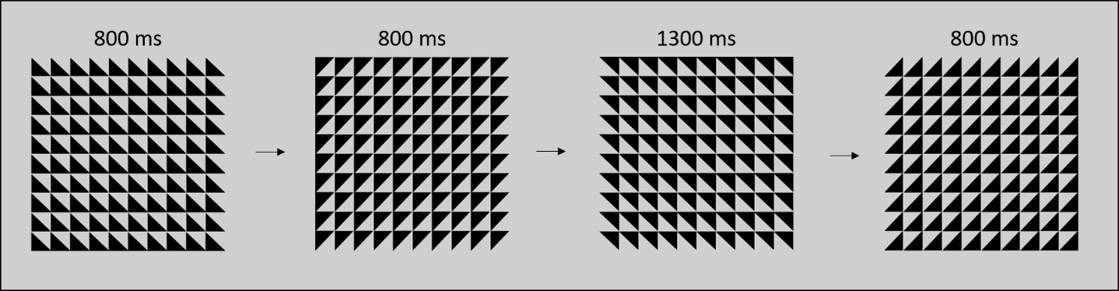

Figure 1:Stimuli used in the continuous time expenctancy task. Adapted from O'Connel et al. (2009)

We used the four visual patterns, as in (O'Connell et al. (2009)). The standard duration in our task was set at 800 ms, while the target duration was set at 1300 ms. The procedure started by a familiarization block, followed by a training one, and ended with a single experimental block. During the familiarization block, 32 patterns appeared one by one on the screen. Four of these patterns were target patterns, while the other ones were standard pattern. Participants had to detect the targets without giving any answer. Training block followed only if participants reported that, during the familiarization block, they noticed some patterns (the target) lasting longer than the other ones. During the training block, they were instructed to press the space bar as soon as they noticed a target. There were 24 trials and among them, 3 targets. If participants were unable to detect the 3 targets during the training block, they had to perform it again until the detection of every target. The experimental block consisted in 674 trials, with 84 targets. Distances between two deviant trials ranged from 4 to 10 trials, with 12 trials for each of these numbers. Following the presentation of a target, participants had 700 ms to answer. For the analysis of results, we then computed the hit rate, which we used as a predictor in our main analysis.

In order to be able to compare our results to previous findings (Jongman, Meyer, et al., 2015; Jongman, Roelofs, et al., 2015a) we also asked our participants to perform a Conjunctive Continuous Performance Task (CCPT;´(Shalev et al., 2011)). In the CCPT, a flow a visual symbol is presented, which vary in shapes (i.e. square, triangle, star, circle) and in color (i.e. blue, green, red, yellow). The task of the participants is to press a button as soon as they see a red square. Because participants have to pay attention to the conjunction of two dimensional features (i.e. shape and color), this task is considered to put increased attentional demands as compared to CPT (Shalev et al., 2011), since it cannot be performed at the pre-attentive level (Treisman & Gelade, 1980). We followed the procedure depicted in Shalev et al. (2011), with participant performing a single block of this task. This block included 320 trials, with 30% of the trials corresponding to the target (i.e. the red square), red non square symbols appearing on 17.5% of the trials, square non red symbols appearing on 17.5% of the trials, and finally non-red and non-square symbols in the remainder of the trials. The inter-trial interval ranged from 1000 ms to 2500 ms, by step of 500 ms. For each participant, we computed the hit rate, as well as the standard deviation of reaction times divided by the mean of the Reaction times (e.g. see (Esterman et al., 2013)). We reasoned that the mean reaction times were likely to be at least partially affected by general processing speed whereas the variance would reflect fluctuation in sustained attention. This method has been recently used in the magnetic resonance literature to track fluctuation of sustained attention almost in real time (e.g. (Esterman et al., 2013; Langner & Eickhoff, 2013)).

Planned analysis

The performances on 2 linguistic variables will be used as inter-individual linguistic metrics:

* The naming latencies in the baseline condition;
* The PWI size effect in the semantical relatedness condition.

Concerning the naming latencies in the baseline condition, we will compute the mean of naming latencies for every participant. Moreover, we will follow the metrics used in Shao et al. (2012) by computing the parameters of the ex-Gaussian distribution of naming latencies. Therefore, we will compute the µ and τ parameters for every participant.

Concerning the PWI size effect in the semantical relatedness condition, we will compute the effect size between the congruent and incongruent condition, by participant.

The performances on several cognitive tasks will be used as predictors:

* The span metric reflecting the inter-individual variability of the updating function;
* The slope of the Simon task reflecting the inter-individual variability of the selective inhibition in a non-linguistic domain;
* The slope of the PWI task reflecting the inter-individual variability of the selective inhibition in a linguistic domain;
* The hit rate in the CTET reflecting the inter-individual variability of sustained attention.

We will compare if the correlation between each of these predictor with the performances on the linguistic variables differ between the speed of the task (CD vs. VSD)

Table 1 depicts all of the comparisons that are planned.

Table 1: Planned comparison

|  |  |  |  |  |  |
| --- | --- | --- | --- | --- | --- |
|  | | Predictors | | | |
| Span measure | Slope Simon task | Slope PWI semantic interference | Hit rate CTET |
| Dependent variables | Mean naming baseline condition | CD vs. VSD | CD vs. VSD | CD vs. VSD | CD vs. VSD |
| µ baseline condition | CD vs. VSD | CD vs. VSD | CD vs. VSD | CD vs. VSD |
| τ baseline condition | CD vs. VSD | CD vs. VSD | CD vs. VSD | CD vs. VSD |
| Effect size PWI semantic interference | CD vs. VSD | CD vs. VSD | CD vs. VSD | CD vs. VSD |

measures and other cognitive functions, including inhibition, sustained attention, and working memory. We hypothesize that language production relies more on other functions when more difficult. According to this hypothesis, we expect (1) following Shao: inhibitory metrics should correlate more with interfering size in the time pressured context. (If when having to produce single words in a difficult context, such as when there is time pressure, the participants recruit additional inhibitory resource to produce the appropriate name then the variability of the effect sizes observed in interfering tasks, at the inter-individual level, should depend more on the ability of participants to deploy inhibition. By comparing a PWI task within a time pressured and a non-time pressured context, we should therefore observe inhibitory metrics correlating more with interfering size in the time pressured context. )

(2) slopes correlate to independent metrics of inhibition? This allows us to investigate the domain specificity vs the domain generability of the inhibitory function involved in lexical selection. In order to investigate this question, we use in this experiment both metrics extracted from the linguistic task itself (by relying on the delta plot procedure) and also in independent nonlinguistic metric. One implicit assumption is that if there is a compensation of the right IFG to the left one, in difficult context of production, due to the lower involvement (this part has been shown unreliably in language production experiment) of this area for language in healthy participant, then this part could reflect a more domain general abilities. )

(3) correlations between RT and metrics of inhibition, working memory, sustained attention (-> hypothesis that entire distribution rather than only tail of distribution now that all trials are assumed to be difficult?

Methods

Planned analyses

Results

General Discussion

Beyond properties at the item and participant levels accounting for latencies in a particular task, it is likely that contextual features of a task are also affecting performances. Such contextual effects have been shown in different domains. Participants can adjust their performances to requirement of the tasks that are made explicit such as rewards, or by tracking and adjusting their own performances. For instance, it has been shown that rewarding participants affect response times (in what task?e.g. Cappa et al., 2013), enhance perceptual discrimination (e.g. Engelmann et al., 2009), short-term memory (Jimura et al., 2010), and inhibitory control (Chung et al., 2011; Yamaguchi et al., 2019). Studies demonstrate that in tasks involving top-down control, where participants have to process congruent and incongruent stimuli (e.g. in the Stroop task with congruent or incongruent color-word combinations), differences in response time(RT) between incongruent and congruent trials is usually larger following congruent trials than following incongruent trials (Gratton et al., 1992). This effect called the *Gratton* effect and demonstrate that performances of participants at a particular trial is affected by what happened at the previous trial.

The existence of such contextual effect have been shown in single word studies, although the extent to which they affect inter and intra individual variability in naming latencies is not known. For instance, Shitova el al. (2017) demonstrated the presence of the *Gratton* effect in the picture word interference task (PWI; Glaser, 1984). In this task, participants have to produce the name of a picture displayed along a word distractor, this word distractor being either semantically related or unrelated to the picture. Usually in this paradigm, larger latencies are observed for the related condition as compared to the unrelated one. One theoretical explanations of this effect is given by the lexical selection-by-competition account (Levelt et al., 1999) of single word production. According to this account, when a single word has to be produced, a lemma need to be selected. The selection process would be competitive, meaning that in order for the correct lemma to be produced, alternative candidates would need to be inhibited. Hence, in the context of the PWI task, the effect of the distractor would be to increase the activation of the alternatives candidates and thereby to increase the level of competition occurring during lemma selection. According to Shitova et al., 2017, the Gratton effect in the PWI (, within the lexical selection-by-competition account), indicates that lexical selection is a process that could be dependent of particular context of production, and under participant control.

If inhibition is involved in word production, then surely there are neural tissues involved in this particular mechanism. Studies are suggesting a dissociation between areas dedicated to lexical activation and lexical selection (e.g. Piai et al., 2014; Schnur et al., 2009). Activity in the left inferior frontal gyrus (IFG) would be involved in the resolving the competition among various candidate, while activity in the left middle temporal gyrus (MTG) in the activation of these candidate. Observations from aphasic patients following a stroke located in the left hemisphere however suggests that this area can be partially compensated by its right counterpart (for a review, see Ries et al., 2016), and interestingly when the difficulty of the production task increase, activity within the right IFG increase (e.g. Hocking et al., 2009; Buckner et al., 1995; Vartanian et al., 2005).

Ballard, J. C. (2001). Assessing attention: Comparison of response-inhibition and traditional continuous performance tests. *Journal of Clinical and Experimental Neuropsychology*, *23*(3), 331–350.

Balota, D. A., & Yap, M. J. (2011). Moving beyond the mean in studies of mental chronometry: The power of response time distributional analyses. *Current Directions in Psychological Science*, *20*(3), 160–166.

Conway, A. R., Kane, M. J., Bunting, M. F., Hambrick, D. Z., Wilhelm, O., & Engle, R. W. (2005). Working memory span tasks: A methodological review and user’s guide. *Psychonomic Bulletin & Review*, *12*(5), 769–786.

Cook, A. E., & Meyer, A. S. (2008). Capacity demands of phoneme selection in word production: New evidence from dual-task experiments. *Journal of Experimental Psychology: Learning, Memory, and Cognition*, *34*(4), 886.

Corsi, P. M. (1973). *Human memory and the medial temporal region of the brain.* ProQuest Information & Learning.

Damian, M. F., Vigliocco, G., & Levelt, W. J. (2001). Effects of semantic context in the naming of pictures and words. *Cognition*, *81*(3), B77–B86.

Draheim, C., Harrison, T. L., Embretson, S. E., & Engle, R. W. (2018). What item response theory can tell us about the complex span tasks. *Psychological Assessment*, *30*(1), 116.

Duñabeitia, J. A., Crepaldi, D., Meyer, A. S., New, B., Pliatsikas, C., Smolka, E., & Brysbaert, M. (2017). MultiPic: A standardized set of 750 drawings with norms for six European languages. *The Quarterly Journal of Experimental Psychology*, *just-accepted*, 1–24.

Engle, R. W., Tuholski, S. W., Laughlin, J. E., & Conway, A. R. (1999). Working memory, short-term memory, and general fluid intelligence: A latent-variable approach. *Journal of Experimental Psychology: General*, *128*(3), 309.

Esterman, M., Noonan, S. K., Rosenberg, M., & DeGutis, J. (2013). In the zone or zoning out? Tracking behavioral and neural fluctuations during sustained attention. *Cerebral Cortex*, *23*(11), 2712–2723.

Ferreira, V. S., & Pashler, H. (2002). Central bottleneck influences on the processing stages of word production. *Journal of Experimental Psychology: Learning, Memory, and Cognition*, *28*(6), 1187.

Forstmann, B. U., Jahfari, S., Scholte, H. S., Wolfensteller, U., van den Wildenberg, W. P., & Ridderinkhof, K. R. (2008). Function and structure of the right inferior frontal cortex predict individual differences in response inhibition: A model-based approach. *Journal of Neuroscience*, *28*(39), 9790–9796.

Foster, J. L., Shipstead, Z., Harrison, T. L., Hicks, K. L., Redick, T. S., & Engle, R. W. (2015). Shortened complex span tasks can reliably measure working memory capacity. *Memory & Cognition*, *43*(2), 226–236.

Garrod, S., & Pickering, M. J. (2007). Automaticity of language production in monologue and dialogue. In *Automaticity and control in language processing* (pp. 19–38). Psychology Press.

Geranmayeh, F., Brownsett, S. L., & Wise, R. J. (2014). Task-induced brain activity in aphasic stroke patients: What is driving recovery? *Brain*, *137*(10), 2632–2648.

Glaser, M. O., & Glaser, W. R. (1982). Time course analysis of the Stroop phenomenon. *Journal of Experimental Psychology: Human Perception and Performance*, *8*(6), 875.

Harrison, T. L., Shipstead, Z., Hicks, K. L., Hambrick, D. Z., Redick, T. S., & Engle, R. W. (2013). Working memory training may increase working memory capacity but not fluid intelligence. *Psychological Science*, *24*(12), 2409–2419.

Hedge, C., Powell, G., & Sumner, P. (2018). The reliability paradox: Why robust cognitive tasks do not produce reliable individual differences. *Behavior Research Methods*, *50*(3), 1166–1186.

Hommel, B. (1997). Interactions between stimulus-stimulus congruence and stimulus-response compatibility. *Psychological Research*, *59*(4), 248–260.

Indefrey, P., & Levelt, W. J. M. (2004). The spatial and temporal signatures of word production components. *Cognition*, *92*(1–2), 101–144. https://doi.org/10.1016/j.cognition.2002.06.001

Irrmischer, M., van der Wal, C. N., Mansvelder, H. D., & Linkenkaer-Hansen, K. (2018). Negative mood and mind wandering increase long-range temporal correlations in attention fluctuations. *PloS One*, *13*(5).

Jongman, S. R., Meyer, A. S., & Roelofs, A. (2015). The role of sustained attention in the production of conjoined noun phrases: An individual differences study. *PloS One*, *10*(9), e0137557.

Jongman, S. R., Roelofs, A., & Meyer, A. S. (2015a). Sustained attention in language production: An individual differences investigation. *Quarterly Journal of Experimental Psychology*, *68*(4), 710–730. https://doi.org/10.1080/17470218.2014.964736

Jongman, S. R., Roelofs, A., & Meyer, A. S. (2015b). Sustained attention in language production: An individual differences investigation. *The Quarterly Journal of Experimental Psychology*, *68*(4), 710–730. https://doi.org/10.1080/17470218.2014.964736

Kornblum, S. (1994). The way irrelevant dimensions are processed depends on what they overlap with: The case of Stroop-and Simon-like stimuli. *Psychological Research*, *56*(3), 130–135.

Laganaro, M., Valente, A., & Perret, C. (2012). Time course of word production in fast and slow speakers: A high density ERP topographic study. *NeuroImage*, *59*(4), 3881–3888.

Langner, R., & Eickhoff, S. B. (2013). Sustaining attention to simple tasks: A meta-analytic review of the neural mechanisms of vigilant attention. *Psychological Bulletin*, *139*(4), 870.

Lehrl, S. (1975). *Mehrfachwahl-Wortschatztest MWT-B Erlangen*. perimed Verlag.

Levelt, W. J., Roelofs, A., & Meyer, A. S. (1999). A theory of lexical access in speech production. *Behavioral and Brain Sciences*, *22*(1), 1–38.

Logan, G. D., & Cowan, W. B. (1984). On the ability to inhibit thought and action: A theory of an act of control. *Psychological Review*, *91*(3), 295.

Mathôt, S., Schreij, D., & Theeuwes, J. (2012). OpenSesame: An open-source, graphical experiment builder for the social sciences. *Behavior Research Methods*, *44*(2), 314–324.

Matzke, D., Verbruggen, F., & Logan, G. D. (2018). The Stop‐Signal Paradigm. *Stevens’ Handbook of Experimental Psychology and Cognitive Neuroscience*, *5*, 1–45.

Meiran, N. (1996). Reconfiguration of processing mode prior to task performance. *Journal of Experimental Psychology: Learning, Memory, and Cognition*, *22*(6), 1423.

Miyake, A., Friedman, N. P., Emerson, M. J., Witzki, A. H., Howerter, A., & Wager, T. D. (2000). The unity and diversity of executive functions and their contributions to complex “frontal lobe” tasks: A latent variable analysis. *Cognitive Psychology*, *41*(1), 49–100.

O’Connell, R. G., Dockree, P. M., Robertson, I. H., Bellgrove, M. A., Foxe, J. J., & Kelly, S. P. (2009). Uncovering the neural signature of lapsing attention: Electrophysiological signals predict errors up to 20 s before they occur. *Journal of Neuroscience*, *29*(26), 8604–8611.

Piai, V., & Roelofs, A. (2013). Working memory capacity and dual-task interference in picture naming. *Acta Psychologica*, *142*(3), 332–342.

Posner, M. I., & Petersen, S. E. (1990). The attention system of the human brain. *Annual Review of Neuroscience*, *13*(1), 25–42.

Proctor, R. W., Miles, J. D., & Baroni, G. (2011). Reaction time distribution analysis of spatial correspondence effects. *Psychonomic Bulletin & Review*, *18*(2), 242–266.

Rey-Mermet, A., & Gade, M. (2018). Inhibition in aging: What is preserved? What declines? A meta-analysis. *Psychonomic Bulletin & Review*, *25*(5), 1695–1716.

Ridderinkhof, K. R. (2002). Activation and suppression in conflict tasks: Empirical clarification through distributional analyses. *Attention and Performance XIX: Common Mechanisms in Perception and Action*, 494–519.

Ridderinkhof, K. R., Scheres, A., Oosterlaan, J., & Sergeant, J. A. (2005). Delta plots in the study of individual differences: New tools reveal response inhibition deficits in AD/Hd that are eliminated by methylphenidate treatment. *Journal of Abnormal Psychology*, *114*(2), 197.

Riès, S. K., Dronkers, N. F., & Knight, R. T. (2016). Choosing words: Left hemisphere, right hemisphere, or both? Perspective on the lateralization of word retrieval. *Annals of the New York Academy of Sciences*, *1369*(1), 111.

Roelofs, A. (2008). Attention, gaze shifting, and dual-task interference from phonological encoding in spoken word planning. *Journal of Experimental Psychology: Human Perception and Performance*, *34*(6), 1580.

Rouder, J. N., & Haaf, J. M. (2019). A psychometrics of individual differences in experimental tasks. *Psychonomic Bulletin & Review*, *26*(2), 452–467.

Scerrati, E., Lugli, L., Nicoletti, R., & Umiltà, C. (2017). Comparing Stroop-like and Simon effects on perceptual features. *Scientific Reports*, *7*(1), 17815.

Shalev, L., Ben-Simon, A., Mevorach, C., Cohen, Y., & Tsal, Y. (2011). Conjunctive Continuous Performance Task (CCPT)—A pure measure of sustained attention. *Neuropsychologia*, *49*(9), 2584–2591.

Shao, Z., Meyer, A. S., & Roelofs, A. (2013). Selective and nonselective inhibition of competitors in picture naming. *Memory & Cognition*, *41*(8), 1200–1211.

Shao, Z., Roelofs, A., Martin, R. C., & Meyer, A. S. (2015). Selective inhibition and naming performance in semantic blocking, picture-word interference, and color–word Stroop tasks. *Journal of Experimental Psychology: Learning, Memory, and Cognition*, *41*(6), 1806.

Shao, Z., Roelofs, A., & Meyer, A. S. (2012). Sources of individual differences in the speed of naming objects and actions: The contribution of executive control. *The Quarterly Journal of Experimental Psychology*, *65*(10), 1927–1944.

Shipstead, Z., Redick, T. S., & Engle, R. W. (2012). Is working memory training effective? *Psychological Bulletin*, *138*(4), 628.

Treisman, A. M., & Gelade, G. (1980). A feature-integration theory of attention. *Cognitive Psychology*, *12*(1), 97–136.

Tse, C.-S., Balota, D. A., Yap, M. J., Duchek, J. M., & McCabe, D. P. (2010). Effects of healthy aging and early stage dementia of the Alzheimer’s type on components of response time distributions in three attention tasks. *Neuropsychology*, *24*(3), 300.

Turner, M. L., & Engle, R. W. (1989). Is working memory capacity task dependent? *Journal of Memory and Language*, *28*(2), 127–154.

Unsworth, N., Heitz, R. P., Schrock, J. C., & Engle, R. W. (2005). An automated version of the operation span task. *Behavior Research Methods*, *37*(3), 498–505.

Unsworth, N., Redick, T. S., Heitz, R. P., Broadway, J. M., & Engle, R. W. (2009). Complex working memory span tasks and higher-order cognition: A latent-variable analysis of the relationship between processing and storage. *Memory*, *17*(6), 635–654.

Van Den Wildenberg, W. P., Wylie, S. A., Forstmann, B. U., Burle, B., Hasbroucq, T., & Ridderinkhof, K. R. (2010). To head or to heed? Beyond the surface of selective action inhibition: A review. *Frontiers in Human Neuroscience*, *4*, 222.

Verbruggen, F., Chambers, C. D., & Logan, G. D. (2013). Fictitious inhibitory differences: How skewness and slowing distort the estimation of stopping latencies. *Psychological Science*, *24*(3), 352–362.

Wechsler, D. (1948). Psychological Corporation; New York: 1987. *Wechsler Memory Scale-Revised.[Google Scholar]*.

Wechsler, David. (2008). Wechsler adult intelligence scale–Fourth Edition (WAIS–IV). *San Antonio, TX: NCS Pearson*, *22*, 498.

Wöstmann, N. M., Aichert, D. S., Costa, A., Rubia, K., Möller, H.-J., & Ettinger, U. (2013). Reliability and plasticity of response inhibition and interference control. *Brain and Cognition*, *81*(1), 82–94.

1. These tasks are available from the Georgia Tech Attention and Working Memory Lab website (<http://englelab.gatech.edu>), we used their scripts to implement them in OpenSesame (Mathôt et al., 2012).